**Research paper- Handwriting Analysis for Detection of Personality Traits Using Deep Learning**

**A PROJECT REPORT**

***Submitted by***

**Shubham Singh(**21BCE10456)

**Harshita Nimje**(21BCE10524)

**Stuti Yadav**(21BCE10543)

**Pritha Dey**(21BCE10707)

*in partial fulfillment for the award of the degree*

*of*

**BACHELOR OF TECHNOLOGY**

*in*

**COMPUTER SCIENCE AND ENGINEERING**



**SCHOOL OF COMPUTING SCIENCE AND ENGINEERING**

**VIT BHOPAL UNIVERSITY**

**KOTHRI KALAN, SEHORE**

**MADHYA PRADESH - 466114**

February 2023

**VIT BHOPAL UNIVERSITY, KOTHRI KALAN, SEHORE**

**MADHYA PRADESH – 466114**

**BONAFIDE CERTIFICATE**

Certified that this project report titled “**Research paper- Handwriting Analysis for Detection of Personality Traits using Deep Learning**” is the bonafide work of “**Shubham Singh(21BCE10456), Harshita Nimje(21BCE10524), Stuti Yadav(21BCE10543), Pritha Dey (21BCE10707)**” who carried out the project work under my supervision. Certified further that to the best of my knowledge the work reported here does not form part of any other project / research work on the basis of which a degree or award was conferred on an earlier occasion on this or any other candidate.

**PROGRAM CHAIR PROJECT GUIDE**

**Dr. Sandip Mal Dr. Monoj Kumar Muchahari**

School of Computer Science and Engineering School of Computer Science and Engineering

VIT BHOPAL UNIVERSITY VIT BHOPAL UNIVERSITY

The Project Exhibition II Examination is held on 14/02/2023

**ACKNOWLEDGEMENT**

First and foremost I would like to thank the Lord Almighty for His presence and immense blessings throughout the project work.

I wish to express my heartfelt gratitude to Dr. Sandip Mal, Head of the Department, School of

Computer Science and Engineering for much of his valuable support and encouragement in carrying out this work.

I would like to thank my internal guide Mr. Dr. Monoj Kumar Muchahari for continually guiding and actively participating in my project, giving valuable suggestions to complete the project work.

I would like to thank all the technical and teaching staff of the School of Aeronautical Science, who extended directly or indirectly all support.

Last, but not the least, I am deeply indebted to my parents who have been the greatest support while I worked day and night for the project to make it a success.

**LIST OF ABBREVIATIONS**

1. ANN- Artificial Neural Network
2. DB- Database

**LIST OF FIGURES**

| **FIGURE NO.** | **TITLE** | **PAGE NO.** |
| --- | --- | --- |
| 1 | Project Coding flow | 11 |
| 2 | Libraries | 14 |
| 3 | Dataset | 14 |
| 4 | Splitting into sets | 15 |
| 5 | Training datasets | 15 |
| 6 | ANN model | 15 |
| 7 | Uploading code | 16 |
| 8 | Console | 16 |
| 9 | Appscript code | 17 |
| 10 | Html webpage | 17 |

**LIST OF TABLES**

| **TABLE NO.** | **TITLE** | **PAGE NO.** |
| --- | --- | --- |
| 1 | Characteristics of ‘t’ | 12 |
| 2 | Slant characteristics | 13 |
| 3 | Margin characteristics | 14 |

**ABSTRACT**

| **CHAPTER NO.** | **TITLE** | **PAGE NO.** |
| --- | --- | --- |
|  | List of abbreviations  List of figures  List of tables | iii.  iv.  v. |
| 1. | **Introduction**  1.1 Introduction  1.2 Motivation for the work  1.3 Software implemented  1.4 Hardware implemented  1.5 Problem Statement  1.6 Objective of the work  1.7 Organization of thesis  1.8 Summary | 1  1  1  2  2  3  3  5 |
| 2. | **Experimental Data**  2.1 Research Analysis  2.2 Implementation of Code | 6 |
| 3. | **Outputs** | 27 |
| 4. | **Conclusion** | 28 |
| 5. | **References** | 29 |

**Introduction**

Handwriting analysis, also known as “Graphology” is a method of understanding the traits of an individual using his/her handwriting. It can be considered as an excellent tool to detect physiological and psychological issues before they become too severe. As stress management is a need of the hour, it can also be used to detect presence of stress in an individual. Apart from these, handwriting can also be used for a variety of purposes, right from criminal investigation to understanding health. Some employers also use handwriting analysis to screen potential employees for compatibility.

Handwriting is typically unique regardless of style, format, spelling, and content. It helps in understanding personality traits through the strokes and patterns revealed by handwriting. Personality Traits are identified through various physical aspects, including sense, honesty, and other emotions as well. These aspects can be revealed using handwriting analysis.

The analysis may consider size of letters and words, slant, pressure, loops, retracing, connection of letters, dots and spacing.

**Motivation for the work**

Handwriting is also called brain writing. Changes in handwriting of an individual through graphotherapy can lead to adjustment toward positive thinking and can help a great deal to solve many psychological and emotional problems such as low self-esteem, lying tendencies, etc. It also helps in identifying students who are in need of guidance and support as teachers can recognize his/her personality even in online mode.Hence, this is recommended by therapy professionals to better understand human psychology through handwriting.

Due to all these reasons and more, we are motivated to create a work on the analysis of handwriting and understanding an individual’s personality. This will not only help improve communication and understanding between two parties but also in learning more about themselves, as in an individual’s strong and weak points and working on them accordingly.

**Software Implemented**

1. Tensorflow
2. Scikit- learn
3. Matplotlib
4. Pandas
5. openCV
6. Numpy
7. Keras
8. Google Apps Script
9. Google Colab
10. Html
11. Javascript

**Hardware Implemented**

1. Digital Camera
2. Laptop
3. Scanner

**Problem Statement**

The aim was to study and analyze handwriting to detect and understand the personality traits of the person, with the help of deep learning.

**Objective of work**

The objective is to find a link between handwriting and personality of a person and also analyzing the handwriting to understand the personality of that person which can be of use in future for improvement of learning and communication skills and techniques, etc.

**Organization of thesis**

Handwriting analyst called a graphologist analyzes the handwriting on a piece of paper written by the individual writer which is very time taking. And the level of accuracy in the result is totally depending on the knowledge and experience of the graphologist

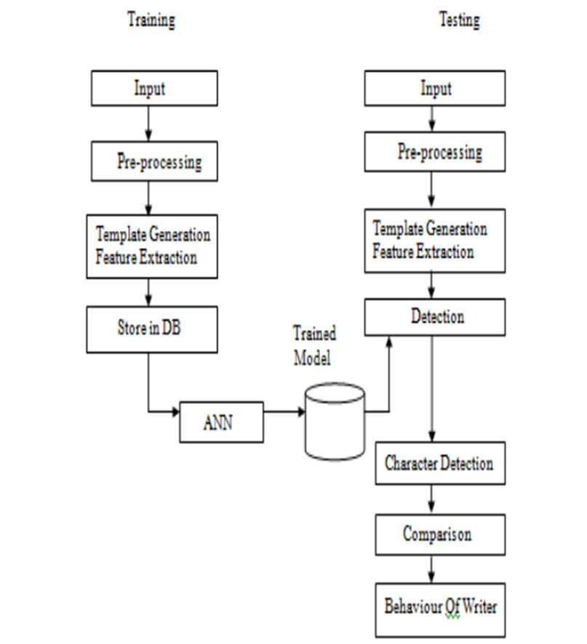

Fig1

The system has two modules. First is the training module and second is the testing module. In training, at first, in our proposed work, the color handwriting documents are collected from surroundings, converted to gray scale handwriting documents. Then sample handwriting images are scanned which are written by different writers on different backgrounds.

**Experimental Data**

**Research Analysis:**

1. Prediction for T character: according to the position of t bar prediction is done.

1) Position of t bar is crossed very high then personality trait is high self esteem

2) Position of t bar is crossed above the

3) middle zone but not at the loop then personality trait is moderate self esteem

4) Position of t-bar is crossed very low on stem low then personality trait is low self esteem.

5) Position of the t bar is crossed above the stem then personality trait is dreamer

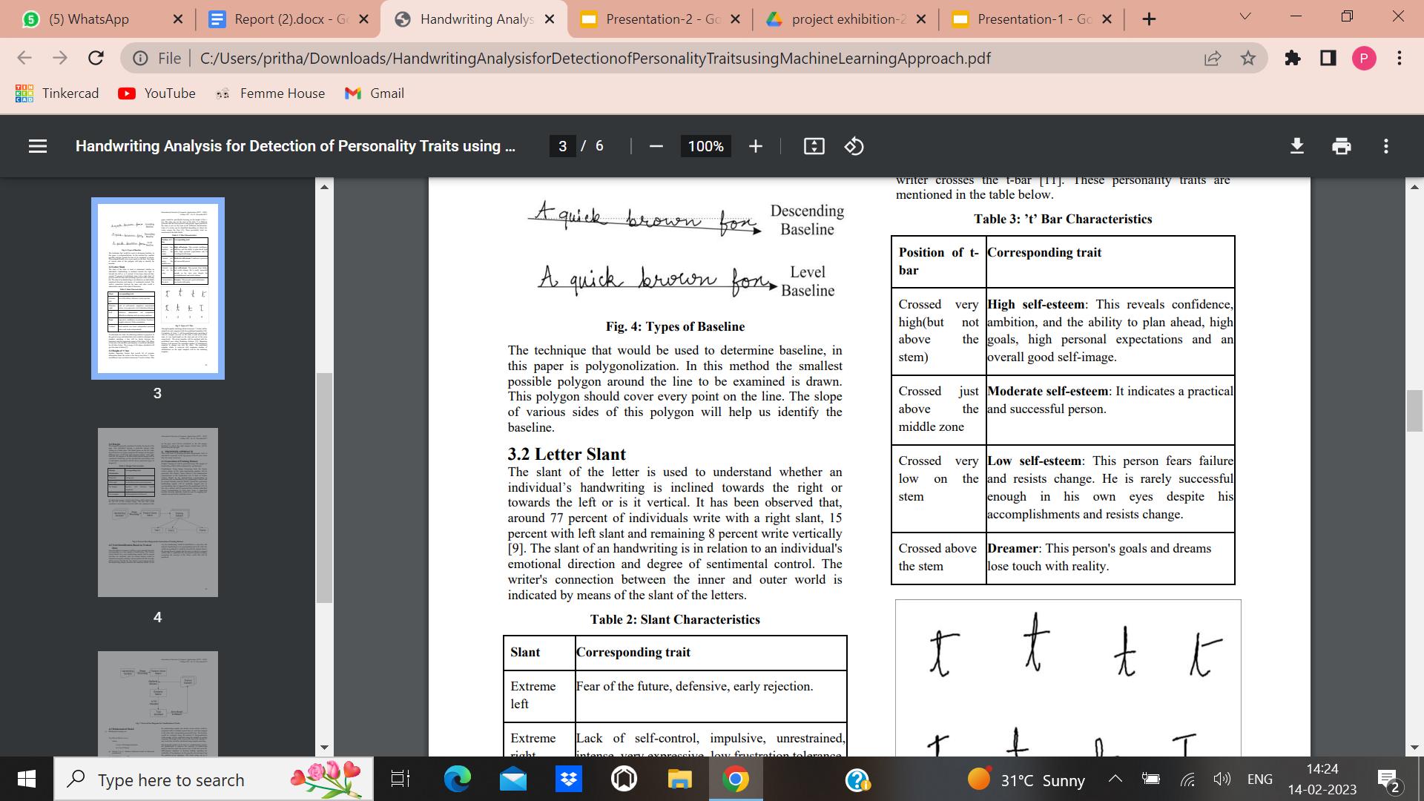 Table 1

1. Prediction for f character: According to the loop of f prediction is done

1) F having a narrow upper loop then personality trait is narrow minded.

2) F loop having angular point then personality trait is resentful, uncompromising.

3) F having an angular loop then personality trait is a strong reaction against interference.

4) F having cross from then personality trait is concentration.

1. Prediction for i character: according to dot on i prediction is done.

1) The high, flying dot then personality trait is curiosity seeker, impatience, enthusiasm

2) The round and justly placed dot then personality trait is detail conscious, accurate , precise and concentration

3) Absence of dot then personality trait is careless , absent, minded

4) Circle of dot then personality trait is frustrated, attention, demanding, imagination, artistic.

5) The left faced dot then personality trait is neurotic

6) The right faced dot then personality is observant.

1. Prediction for a character: according to the lowercase closed

1) Closed at the top and on the right: it reflects introversion, prudence, cautiousness, personality with ability to reserve what must not be disclosed, keeps secrets, controls his emotions.

2) Closed on the left: introversion, shyness, reflection, prudence, cautiousness, pride, inner life, distrust, and little social contact.

3) Closed at the bottom: When the graphology is fast, legible and clear, it is interpreted as agility for thinking, ability for synthesis and planning

4) Closed with a final curl on the right: diplomacy, ability for public relations, and cleverness for business as a goal to obtain advantages. Reservation, prudence, discretion, calculating personality, distrust.

5) With a small inner curl: (minuscule initial curl, located on the superior area) looks for compliments. Desire for caress.

6) Closed with a double curl: (it looks like the oval is formed by two “e” letters). Desire to be liked, to enchant, adjustable passive conduct. Ability to negotiate and for public relations. It may be interpreted as a confusing letter, depending on the rest of the graphical context: hiding.

7) Closed by double turn: diplomacy, reservation, prudence, cautiousness, lies, egocentrism, intrigue, interested expressions. If the oval is divided: commercial skills, diplomacy, and astuteness

8) Closed and pasted: hysteria, stress, accented mental or physical fatigue, mental confusion due to emotional disorder, may be due to intoxication with alcohol or drugs.

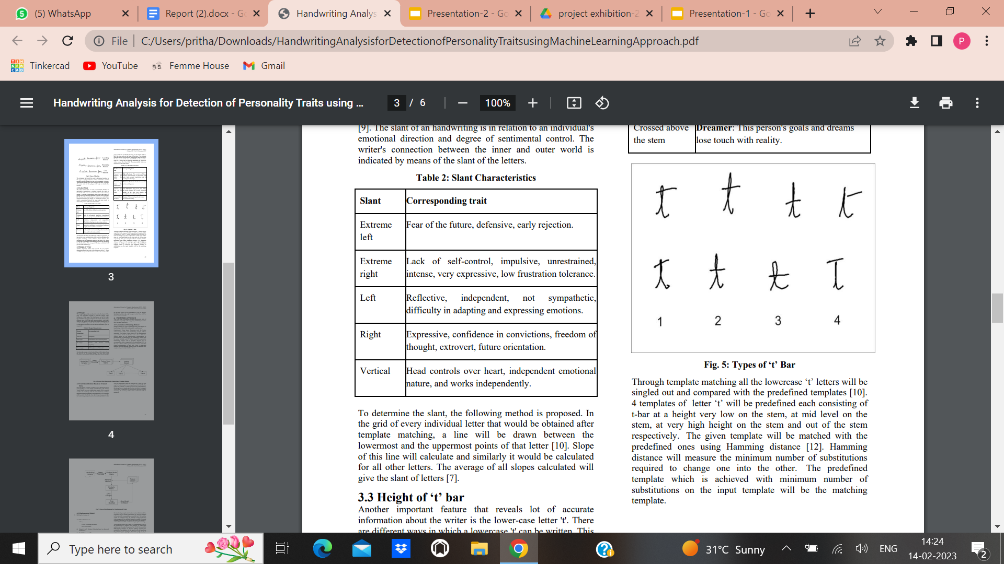

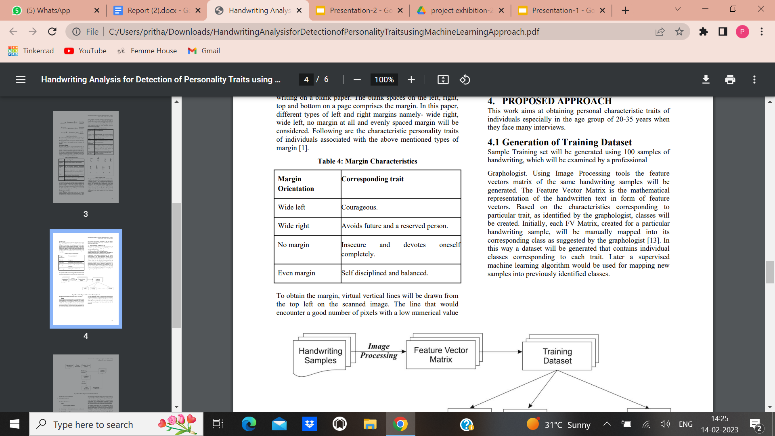

Table 3

**Implementation of code:**

Importing libraries:

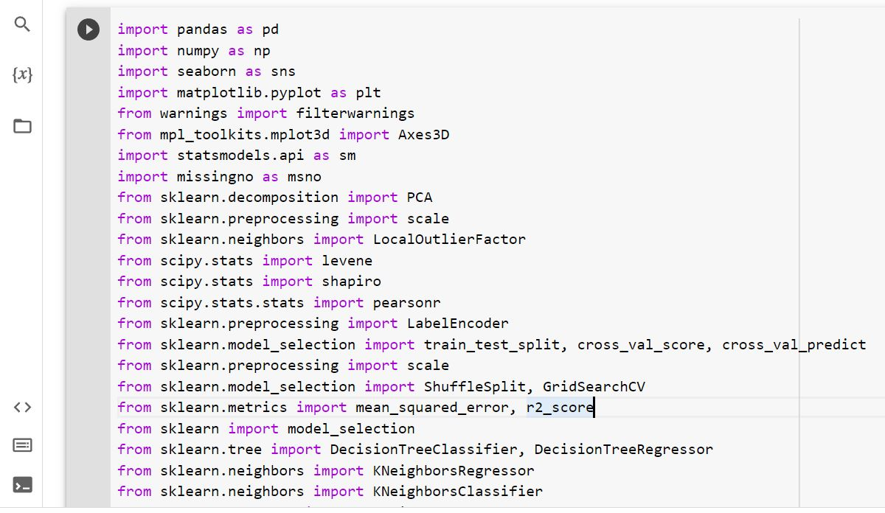Fig 2

Importing the data sets

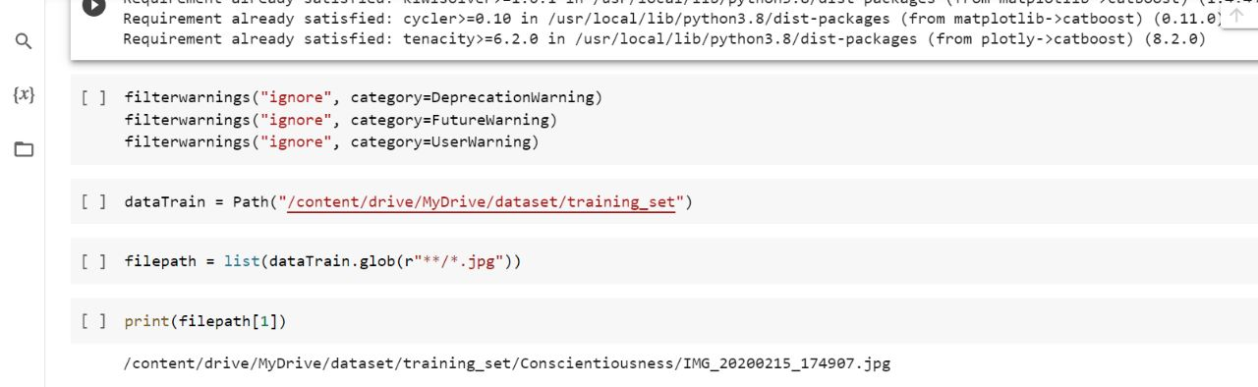Fig 3

Splitting the dataset into the training set and test set

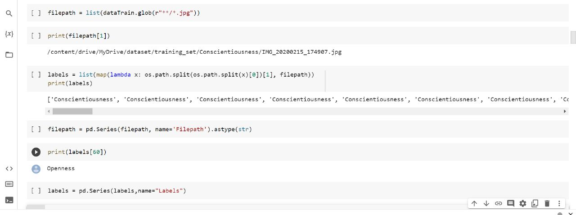Fig 4

Training the model on training set using ANN model

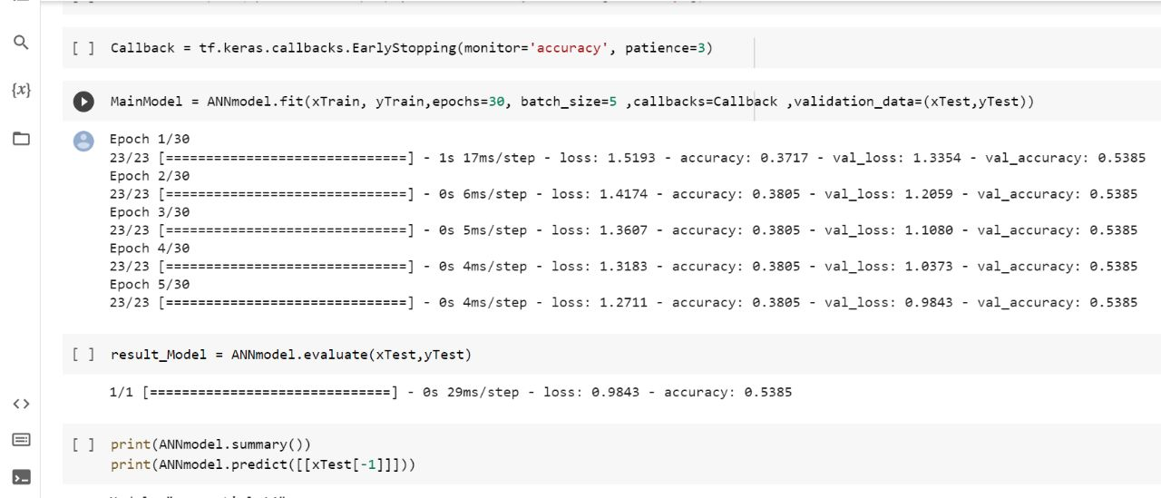Fig 5

Implementing the ANN model

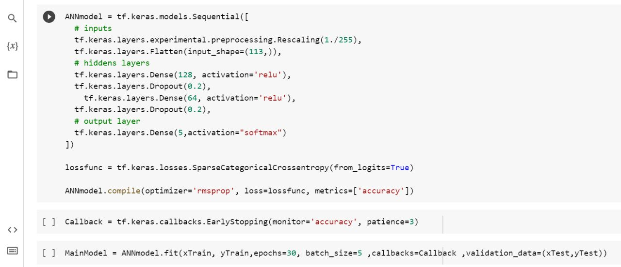Fig 6

**Outputs**

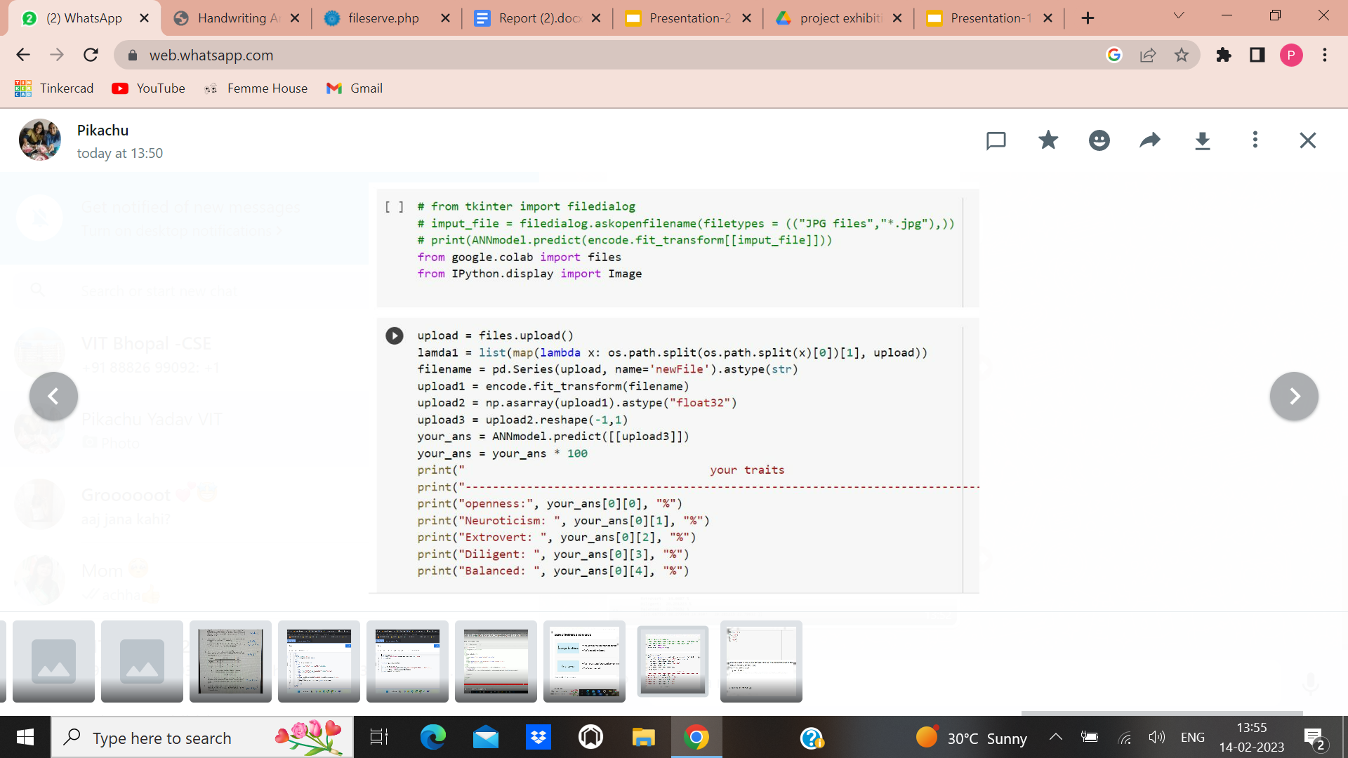

Fig 7

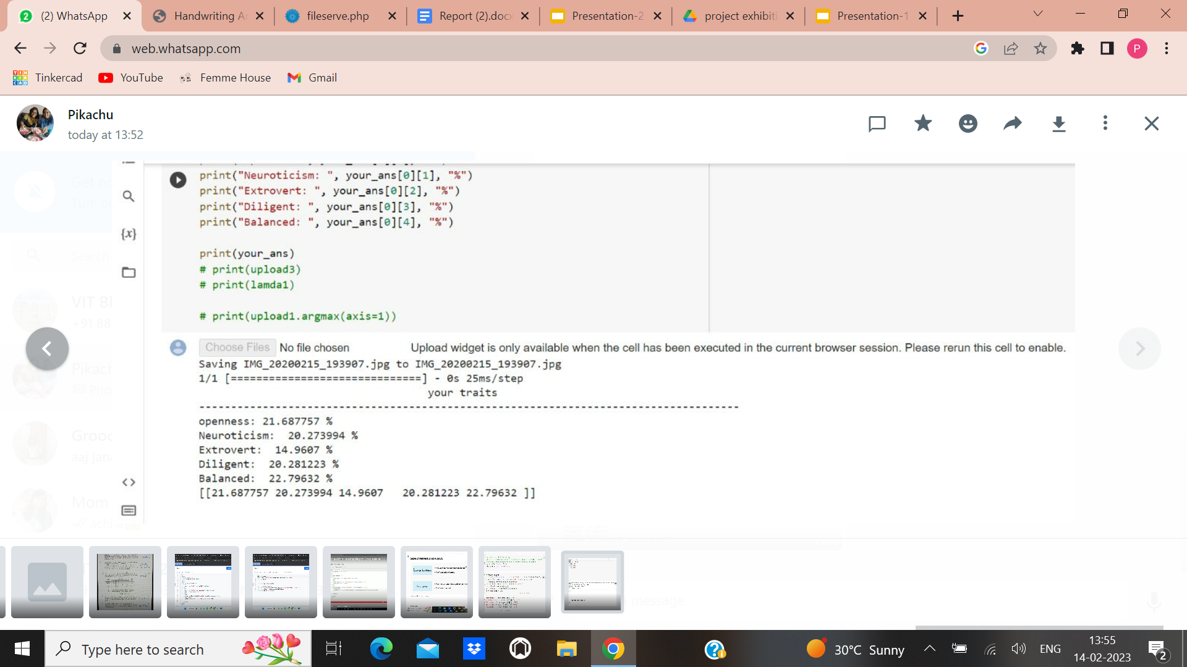

Fig 8

**Openness -** Openness is how open-minded, imaginative, creative and insightful a person is or can be.Openness is the degree to which people are generally open or receptive to all sorts of things.

**Neuroticism -** Neuroticism is the trait disposition to experience negative affects, including anger, anxiety, self‐consciousness, irritability, emotional instability, and depression.

**Extrovert -** An outgoing, gregarious person who thrives in dynamic environments and seeks to maximize social engagement.

**Diligent -** Diligence means that you commit yourself to a cause that is important to you. You know for yourself that a lot is possible, and you follow that high image with enthusiasm and inspiration.

**Balanced -** A balanced personality is marked by good physical appearance, emotional stability, higher intellectual ability.

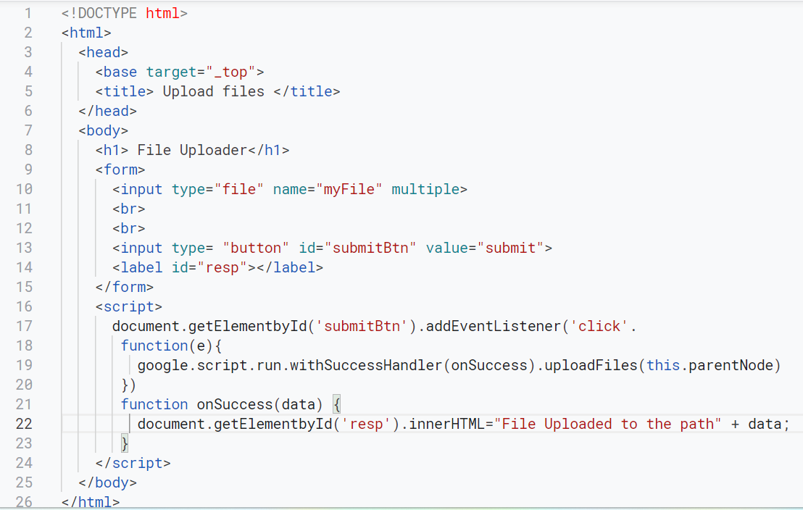

Fig 9

<https://script.google.com/a/macros/vitbhopal.ac.in/s/AKfycbxp3JaKiEh1YSt1XrWnGxVBnGJAWn_YGITx5xVDKTMXjEdhLsIcO-dElYkKN83VYdE/exec>

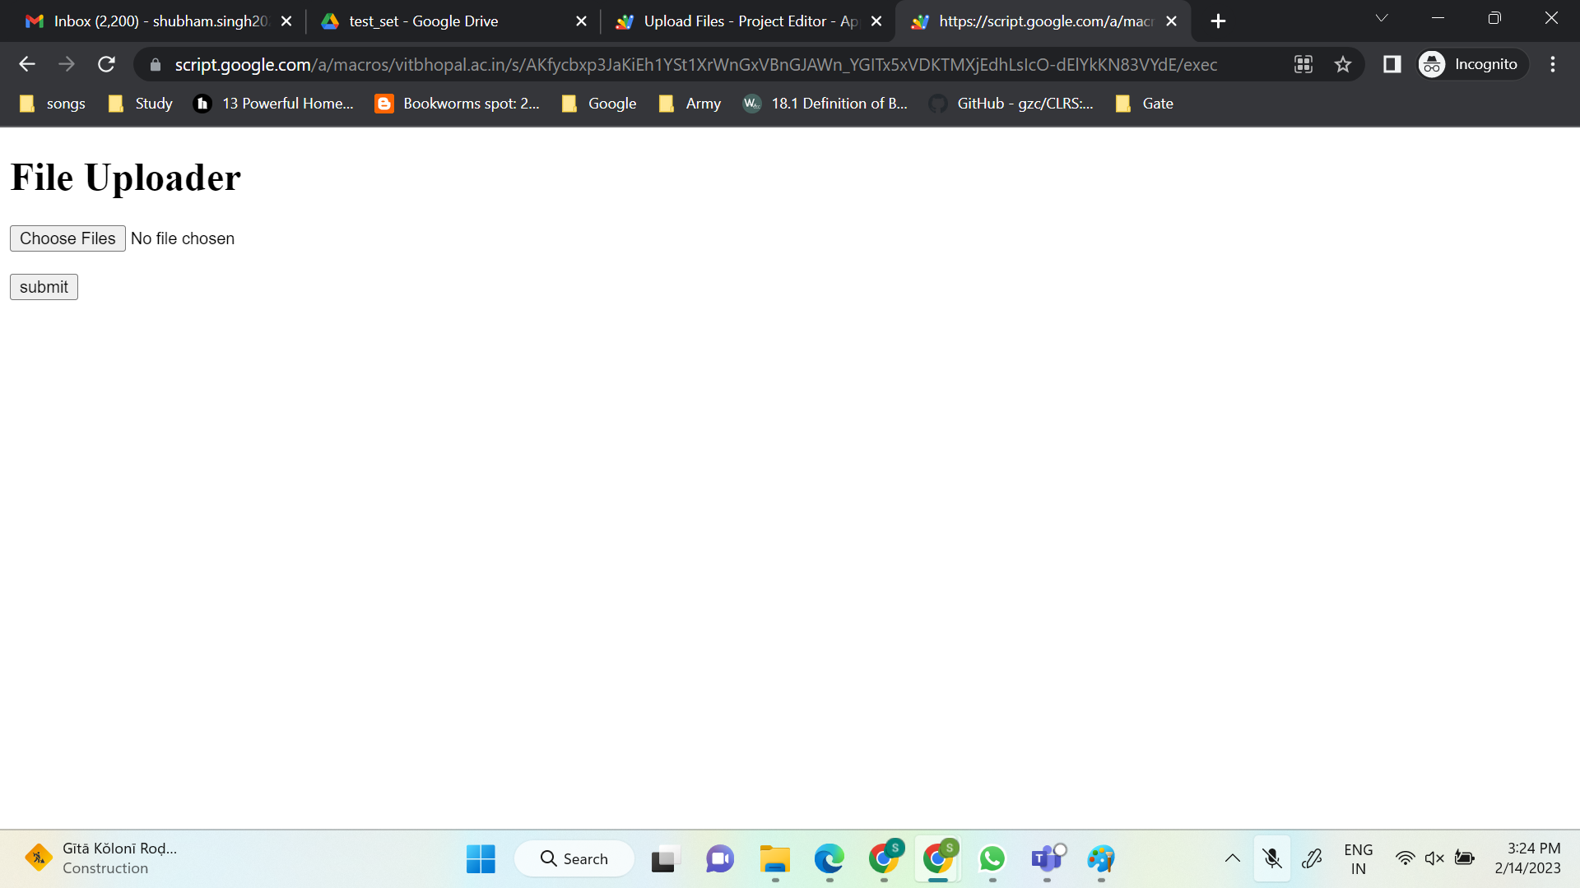

Fig 10

Finally the person can upload here handwritten document here and get his result

**Conclusion**

A method is being developed to predict the behavior of a person from the features extracted from his handwriting. The personality traits determined by letter slant, letter ‘i’, ‘f’, ’a’, ’d’, ’e’, ’g’ and many others as found in an individual's handwriting are explored in this paper. This is input to the ANN which outputs the personality trait of the writer.

Furthermore we have implemented this thesis to make a web app product using Google Appscript for personality analysis based on the above output factors. Hence one does not need to access the code and study it to perform any analysis one just needs to directly upload his/her handwritten page and get the output.

**References**

1. P. Joshi, A. Agarwal, A. Dhavale, R. Suryavanshi, S. Kodolikar. Article: handwriting analysis for detection of personality traits using machine learning approach. Int. J. Comput. Appl. 130(15), 40–45, November 2015. Published by Foundation of Computer Science (FCS), NY, USA.
2. H.N. Champa, K.R. AnandaKumar, Article: artificial neural network for human behavior prediction through handwriting analysis. Int. J. Comput. Appl. 2(2), 36–41 (2010)
3. Chanchlani, Predicting human behavior through handwriting. Int. J. Res. Appl. Sci. Eng. Technol. 624–628 (2017)
4. <https://www.ijraset.com/fileserve.php?FID=10397>
5. <https://link.springer.com/chapter/10.1007/978-981-16-3675-2_40>
6. <https://www.grafos.cl/Articulos/HandwritingAnalysisforDetectionofPersonalityTraitsusingMachineLearningApproach.pdf>